MENAI BRIDGE BOAT CLUB
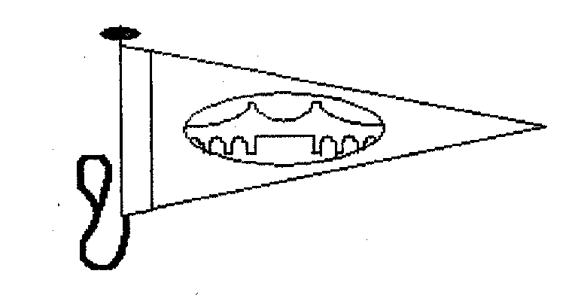

ST GEORGES PIER
Round Anglesey Race

Saturday 30th July 2011
Warning Gun: Class 1 – 0955 hrs Times provisional
Class 2 – 1000 hrs
Class 3 – 1005 hrs

Class 4 – 1010 hrs

Class 1 Channel Handicap (IRC2008) Fast
Class 2 Channel Handicap (IRC2008) Standard
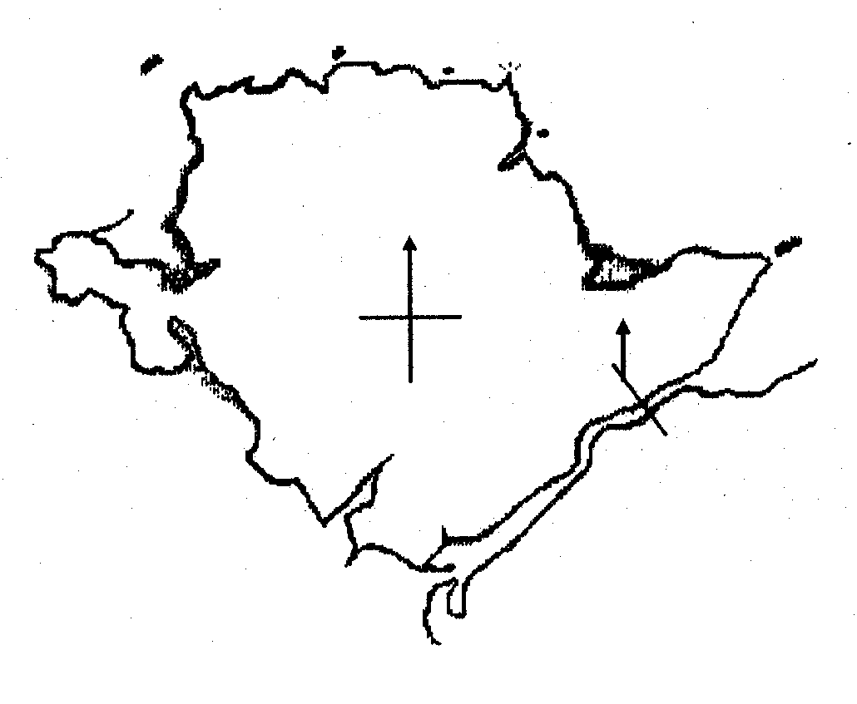
Class 3 Portsmouth Yardstick
Class 4 Multihull

Line Honours
1st The Strait Lady Cup + A bottle of champagne
2nd The Liverpool Arms Salver
Class 1
1st The Webb Salver
2nd The lle d’Yeu Cup
3rd The Liverpool Arms M.B. Rose Bowl
Class 2
1st The Cromarty Cup Free Berthing on Menai Bridge Pier 29th and 30th July
2nd The Thelma Cup
Class 3
1st The Menai Bridge Boat Club Cup
Class 4 To be advised
 | For entry Form and Sailing instructions contact:-
ENTRY FEE  £25  PER YACHT COMPETING | Rob Evans  Vice Commodore  Min Dwr  Beach Rd., Menai Bridge,  Anglesey  LL59 5HB  Tel: 01248 712012  Mobile:  E-mail: menaibridgeboatclub@hotmail.co.uk | Garth Griffith (Race Secretary)  Commodore  1 Menai Terrace  Askew Street  Menai Bridge  Anglesey  LL59 5EL  Tel 01248 714706  Mobile 0797 194 0071
Prize giving will take place after the Menai Bridge Regatta at 18.30hrs on August 8th at the Victoria Hotel Menai Bridge
All boats completing the course will be presented with a plaque if a representative is present at the prize giving

