THE MENAI BRIDGE BOAT CLUB
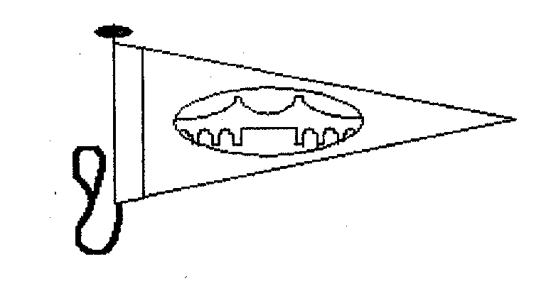

ST GEORGES PIER
Round Anglesey Race

30th July 2011
To be sailed in Four classes under IRC2008 Rating or Portsmouth Yardstick

Yacht (name) …………………………………………
Sail No. ……………………………Sail Insignia
Colour of Hull …………………………………………
IRC Rating/or PY handicap…………………..………..A Valid Certificate (as appropriate) must be held
Class of Boat …………………………………Multihull Yes / NO……………………….
Name of Owner …………………………………………………….……………………………..
Name of Skipper ……………………………………………………………………………………
Contact Address ……………………………………………………………………………………
…………………………………………………………………….………………
………………………………………………………………………….…………
……………………………………………………………………………….……
…………………………………………………………………………………….
Tel. No ……………………………………Fax No……………………………………….
E mail ……………………………………………………………………………………
Club …………………………………………………………………………………….

- I declare I am in possession of all necessary class and Handicap Certificates and that the boat is insured to include Third Party Liability cover of a minimum of £2,000,000.
- I agree to be bound by the Racing Rules of Sailing (R.R.S), the prescriptions of the R.Y.A. and these sailing instructions, in confirmation of which I enclose the entry fee of £25.
- I have read and understood the disclaimer on the back of this entry form.
- The boat conforms to the ISAF Offshore Special Regulations Category 2010-11 Appendix J Category 5. With an addition a VHF and mobile phone.

Cheques made payable to “The Menai Bridge Boat Club” and Entry Form should be sent to the Race Secretary.
Entry form must be signed by the owner or skipper.
SIGNATURE DATE

Race Secretary | Garth Griffiths  1 Menai Terrace, Menai Bridge, Anglesey, LL59 5EL | Tel: 01248 714706

Disclaimer of Liability

- A boat is entirely responsible for her own safety, whether afloat or ashore, and nothing, whether in the Notice of Race or Sailing instructions or anywhere else, reduces this responsibility.

- It is for the boat to decide whether she is fit to sail in the conditions in which she will find herself. By launching or going to sea, the boat confirms that she is fit for those conditions and her crew is competent to sail and compete in them.

- The boat is required to hold adequate insurance and in particular to hold insurance against third party claims in the sum of at least. £2,000,000.

- Nothing done by the organisers can reduce the responsibility of the boat nor will it make the organisers responsible for any loss, damage, death or personal injury, however it may have occurred, as a result of the boat taking part in the racing. The organisers encompass everyone helping to run the race committee, the race officer, patrol boats and beach masters.

- The provision of patrol boats does not relive the boat of her responsibilities.

- The boat is responsible to ensure that she is equipped and seaworthy so as to be able to face extremes of weather; that there is a crew sufficient in number, experience and fitness to withstand such weather; and that the safety equipment is property maintained, stowed and in date and that the crew know how to use it.

.

