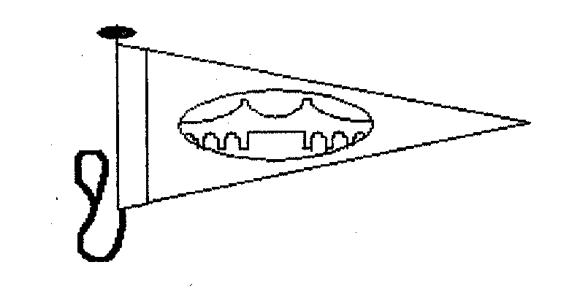

MENAI BRIDGE BOAT CLUB

ST GEORGES PIER
Round Anglesey Race

Menai Bridge
30th July 2011
SAILING INSTRUCTIONS

RULES
The regatta will be governed by the rules as defined in the current Racing Rules of Sailing.

ENTRIES
A) Competitors may enter by delivering a completed entry form and paying the £30 entry fee before the race. Entries on the day shall be accepted at the MBBC Club House before the start.
b) All yachts and equipment shall conform to the ISAF Offshore Special Regulations 2010-11 Appendix J Category 5 governing minimum standards of equipment and accommodation. A VHF radio and a mobile phone shall be carried and the phone number logged with the Race Officer before the race.
c) The safety of a boat and her entire management including insurance shall be the sole responsibility of the owner/person in charge who must ensure that the boat and crew are adequate to face the conditions that may arise in the course of the race. Neither these sailing instructions nor any inspection of the boat limits or reduces the absolute responsibility of the owner/person in charge for the crew, the boat and her management. The race organizers shall not be responsible for any loss, damage, death or personal injury howsoever caused to the owner /person in charge or crew, as a result of their taking part in the race or races. Moreover, every owner/ person in charge warrants the suitability of the boat for the race or races.

NOTICES TO COMPETITORS
Notices to competitors will be posted on the official notice board located at The Menai Bridge Boat Clubhouse.

Schedule and Class Flags
a) The race will be sailed as four classes. All competitors shall display on the backstay the code flag allotted to their respective Class at all times when racing rules apply.
b) Class 1. Channel Handicap IRC will fly code flag Numeral 1
c) Class 2. Channel Handicap IRC will fly code flag Numeral 2
d) Class 3. Portsmouth Yardstick will fly code flag Numeral 3
e) Class 4. Multihull will fly code flag Numeral 4
09.55 (C1) Warning Signal will be given and Code Flag 1 will be displayed
10.00 (C2) Warning Signal will be given and Code Flag 2 will be displayed
10.05 (C3) Warning Signal will be given and Code Flag 3 will be displayed
10.10 (C4) Warning signal will be given and Code Flag 4 will be displayed

RACING AREA
The racing area will be Around Anglesey.

COURSE and MARKS
From Start Line at Menai Bridge, South-westwards through the Menai Strait and South about Anglesey, leaving Penmon Perch to Port thence to finish at Menai Bridge. Minimum Distance 64 nautical miles.

STARTING AND FINISHING LINES
a) Prolongation of a line between 2 poles on Menai Bridge Promenade Barbican, The inner Pole flying M.B.B.C. Burgee, Both Poles having orange Triangles. (Note there will be no limit mark).
b) To assist the Race Officer sail numbers must be clearly illuminated by a high intensity Aldis type lamp when in the vicinity of the Finishing Line during the hours of darkness.

TIME LIMIT
a) Round Anglesey Race 24 hours from the time of their start.
b) If no yacht has crossed the finishing line, the Sailing Committee may at their discretion, place and award prizes to yachts in the order in which they past a point on the course, chosen by the Race Officer.

PROTESTS (Amending Rule 61)
Oral notice of intention to protest shall be made either by radio immediately on crossing the line or as soon as possible thereafter to the R.O. or an official of the Menai Bridge Boat Club, and formal notice in writing on the prescribed form shall be lodged at The Royal Anglesey yacht Club before 18.00hrs on the day following the race start. Protest committee shall be convened if necessary on Tuesday at the Royal Anglesey Y.C. and details shall be placed on the Notice board at the Royal Anglesey Yacht Club. The race committee shall not give any further or other notice to either party.

SCORING
The Low Point System of Appendix A of the racing rules will apply. Regatta series: The points awarded will be as prescribed in the Menai Strait Regatta Programme. The Round Anglesey Race will count for the point’s series of Race 1 IRC and the Concha Cup.

Safety:
a) A radio watch will be maintained on VHF channel 16 by the race organizers. Under heavy weather conditions boats are asked to keep a listening watch on dual channels 16 and 37/M1.
b) Navigation lights will be shown after 21.00 hours BST and until 05.30 hours BST. Between these times, except when otherwise stated in these Sailing Instructions, the RRS part two shall not apply and shall be replaced with the corresponding International Regulations for Preventing Collisions at Sea.
c) Entrants shall conform to the safety regulations appropriate to their class association and may be subject to scrutiny.
d) Competitors should listen to the forecast transmitted on channel M1 at 0900 by the race officer.
e) On passing Holyhead competitors should report progress to the Coastguard at Holyhead.

Retirement:
The owner of any yacht retiring must inform the Race Officer as soon as possible. By VHF radio on channel 37/M1 or telephone 0797.194.0071

Sail Numbers:-
Excepting after special written permission from the Race Officer, sail numbers on mainsail, and spinnaker if carried, shall conform to those declared on entry. Duplicate sail numbers in the same class shall not be acceptable.

OoOOOoo
Extract from International Regulations for preventing collisions at sea.
Rule 9(b) "A vessel of less than 20 metres in length or a sailing vessel shall not impede the passage of a vessel which can safely navigate only within a narrow channel or fairway. Competitors are asked to realize that in the narrow channel of the Menai Strait, navigation for commercial craft is exacting and difficult, all Yachtsmen are requested to bear this in mind and must give way. In the event of an accident with an unattended moored vessel the Pier master at Menai Bridge should be informed Tel 01248 712312

